**Document Vs Window Objects**

A document is an object inside the window object and we use a document object for manipulation inside the document. The first thing that gets loaded into the browser is the window and the properties related to that window are stored in the window object.

## **Document Object:**

The document object represents a web page that is loaded in the browser. By accessing the document object, we can access the element in the HTML page. With the help of document objects, we can add dynamic content to our web page. The document object can be accessed with a **window. document** or just **document.**

**Syntax:**

**Document.property_name;**

## **Window Object**

The window object is the topmost object of the DOM hierarchy. It represents a browser window or frame that displays the contents of the webpage. Whenever a window appears on the screen to display the contents of the document, the window object is created.

**Syntax:**

**Window.property_name;**

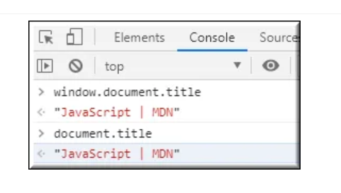

**The other major difference is that both window object and document object have properties and methods. Few method names are same in both objects but with different behavior. In the below example *window.open()* opens a new tab or window and *document.open()* creates a blank document within the window.**

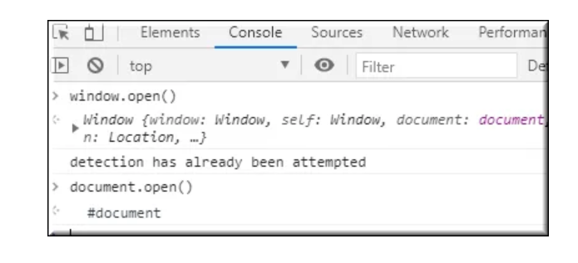

**window.property_name;**

**window.property_name;**

**window.property_name;**